Dashboard and KPIs

Contents:

1. Finance KPIs 2

1.1 Sales and costs 2

1.2 Investment 3

1.3 Cash Flow 3

1.4 Capital 4

1.5 Liabilities and debts 4

2. Manufacturing performance 5

2.1 Manufacturing and Productivity: 5

2.2 Quality 7

2.3 Supply Chain and logistic: 8

# 1. Finance KPIs

## Sales and costs

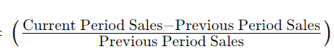

1. **Sales variation Rate =**

Significance: the percentage change in sales over a specific period, providing insights into the sales performance dynamics and trends.

1. **Sales map** = Sales per country

Significance: visualizes sales performance across different countries, aiding in the identification of geographical sales patterns and opportunities.

1. **Top customer with number of order and revenue**

Significance: highlights the most valuable customers by displaying their order count and associated revenue, helping prioritize and manage key client relationships.

1. **Costs per department and variation**

Significance: assisting in cost management and identifying areas for efficiency improvement or resource allocation.

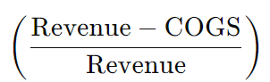

1. **Gross profit margin =**

Significance: expresses the percentage of revenue retained after deducting the cost of goods sold, indicating the profitability of core business operations.

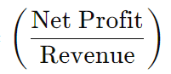

1. **Net profit margin =**

Significance: represents the percentage of profit remaining after deducting all expenses, providing a comprehensive view of overall profitability and financial health.

## Investment



1. **Return on Investment (ROI)=**

Significance: the profitability of an investment by expressing the gained or lost value as a percentage of the initial investment, aiding in assessing the efficiency of capital utilization.

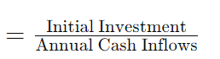

1. **Payback period**

Significance: indicates the time it takes for an investment to recover its initial cost through generated cash flows, providing insights into the investment's risk and return profile.

## Cash Flow

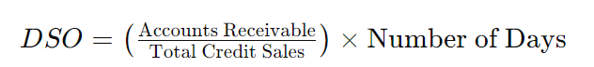

1. **Days Sales Outstanding** =

Significance: measures the average number of days it takes for a company to collect payment after a sale, reflecting the effectiveness of credit and collection policies in managing accounts receivable.

1. **Cash to cash cycle =** Nb days of inventory + Nb days of payable – Nb days of receivable

Significance: calculates the time it takes for a company to convert its investment in inventory and accounts receivable into cash by considering the number of days of inventory, accounts payable, and accounts receivable.

1. **Working Capital Requirement (WCR)** = Inventory + Accounts Receivable − Accounts Payable

Significance: represents the capital needed to fund the day-to-day operations, calculated as the sum of inventory, accounts receivable, and accounts payable, helping assess liquidity and financial health.

## Capital

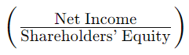

1. Return on Equity (ROE) **=**

Significance: measures the profitability of a company in relation to its equity, expressing net income as a percentage of shareholders' equity, indicating the efficiency of equity utilization.



1. Return on Assets (ROA) =

Significance: evaluates a company's efficiency in generating profits from its assets by expressing net income as a percentage of total assets, providing insights into operational efficiency.

## Liabilities and debts

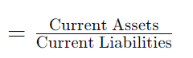

1. **Current Ratio**

Significance: assesses a company's ability to cover short-term liabilities with its short-term assets, indicating liquidity and the ability to meet immediate financial obligations.

1. **Working Capital** = Current Assets − Current Liabilities

Significance: represents the difference between a company's current assets and current liabilities, providing an indicator of its short-term financial health and operational liquidity.

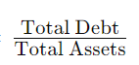

1. **Debt Ratio** =

Significance: expresses the proportion of a company's total assets funded by debt, providing insights into the level of financial leverage and the potential risk associated with the company's capital structure.



1. **Quick Ratio (Acid-Test Ratio)** =

Significance: assesses a company's ability to cover its short-term liabilities with its most liquid assets, excluding inventory, providing a more conservative measure of liquidity.

# 2. Manufacturing performance

## Manufacturing and Productivity:

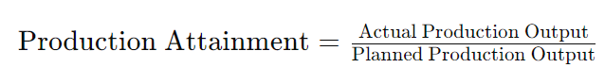

Significance: measures the extent to which actual production output matches the planned or targeted production, offering insights into operational efficiency and goal achievement.



Significance: evaluates the efficiency of resource utilization in producing goods or services, often expressed as output per unit of input, helping assess operational efficiency.

1. **Overall Equipment Effectiveness (OEE)** =

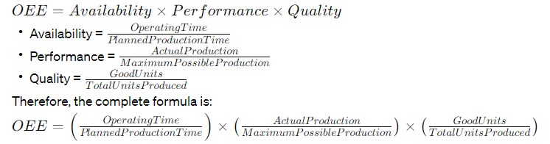

Significance: is a comprehensive metric that evaluates the efficiency of manufacturing equipment by considering availability, performance, and quality, providing a holistic view of equipment performance.

1. **Machine set-up time =**Time required to prepare machine for next run

Significance: measures the duration required to prepare a machine for a specific production task, impacting overall production efficiency and responsiveness.



1. **Mean Time Between Failure (MTBF) =**

Significance: calculates the average time a machine or system operates between failures, providing insights into equipment reliability and maintenance planning.



1. **Mean Time to Failure (MTTF) =**

Significance: estimates the average time a system or component operates before experiencing a failure, contributing to reliability assessments and preventive maintenance strategies.

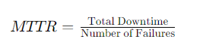

1. **Mean Time to Repair (MTTR) =**

Significance: measures the average time it takes to restore a machine or system to operational status after a failure, aiding in downtime management and maintenance efficiency.



Significance: gauges the overall reliability of equipment within a system, combining various reliability metrics to provide a comprehensive assessment.

1. **Equipment Downtime =** (Time Out of Service)

Significance: quantifies the time during which equipment or machinery is not operational, influencing production schedules and efficiency.

1. **Production Order Cycle Time =** (Prod Completion Date - Prod Order Creation Date)

Significance: measures the total time required to complete a production order, including processing, setup, and waiting times, providing insights into production efficiency.

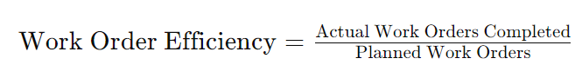

Significance: assesses the effectiveness of work order execution by comparing planned versus actual completion times, aiding in performance evaluation and process improvement.

## Quality

1. **Cost of Poor Quality (COPQ)** = External + Internal poor quality

= Cost of Repairs + Cost of Rejects + Cost of Product Returns + Cost of Extra Inspections

Significance: includes both external and internal costs related to poor quality, encompassing expenses like repairs, rejects, product returns, and additional inspections, providing a comprehensive view of quality-related financial implications.

1. **Scrap material value =**(Quantity scrapped x unit standard cost)

Significance: calculates the cost of scrapped material by multiplying the quantity scrapped by the unit standard cost, quantifying the financial impact of material wastage.

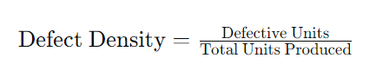



Significance: measures the number of defects per unit of measurement, aiding in assessing the quality level of a product or process.





Significance: represents the percentage of products that pass through a process without requiring rework or correction on the first attempt, reflecting production efficiency and quality.

## Supply Chain and logistic:

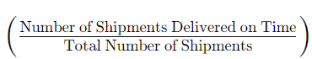

1. **% On time shipment =**

Significance: calculates the percentage of shipments that are delivered on time, providing insights into the reliability of the supply chain in meeting customer expectations.

1. **Shipment Lead Time =** Scheduled Shipment Date − Order Placement Date

Significance: measures the duration between the scheduled shipment date and the order placement date, offering insights into the time it takes for goods to be prepared for shipping.

1. **% On time delivery =**

Significance: represents the percentage of orders delivered on time, offering a metric for evaluating the punctuality of the delivery process.

1. **Order-to-Delivery Time =** Delivery Date − Order Placement Date

Significance: calculates the duration from the order placement date to the delivery date, providing insights into the overall time required to fulfill customer orders.

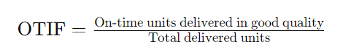

1. **Delivered on Time and In Full =**

Significance: evaluates the percentage of orders delivered both on time and with complete fulfillment, measuring the effectiveness of order fulfillment processes.

1. **Dock-to-Stock Cycle Time =** Time from Receiving to Stocking

Significance: measures the time taken from receiving goods to stocking them, indicating the efficiency of the receiving and stocking processes.



1. **Inventory Turns** =

Significance: quantify how many times a company's inventory is sold and replaced within a specific period, providing insights into inventory management efficiency.

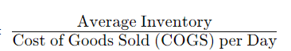

1. **Inventory days of supply** =

Significance: calculates the number of days the existing inventory can sustain sales, aiding in inventory planning and control.

1. 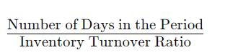**Days Sales of Inventory = DSI =**

Significance: represents the average number of days it takes for a company to sell its entire inventory, offering insights into inventory turnover.

1. **Out of stock items** = Number of Items with Inventory Level ≤ 0

Significance: count the number of items with inventory levels at or below zero, indicating potential issues in inventory management and fulfillment.

1. **Lead time =**Order process time + production lead time + delivery lead time

Significance: includes order processing time, production lead time, and delivery lead time, providing a comprehensive measure of the time required to fulfill customer orders.

1. **9 boxes =** ABC XYZ

Significance: is a classification system that categorizes items based on their importance (ABC) and variability (XYZ), helping prioritize inventory management efforts for different items.